POC: Infrastructure as a code

Create a process which will show you how to automate your infrastructure related tasks and deployment tasks using Devops tools like Jenkins, Chef/Puppet and AWS/AZURE.

Problem Statement: Install Jenkins master using chef cookbook in
AWS EC2 instance

Pre requisites:
- Chefdk
- Chef server
- Jenkins server
- Aws account

Developing Chef Cookbook:

- Download the Jenkins cookbook from supermarket along with all its dependencies
Command: knife cookbook site download Jenkins
- Customize the cookbook as per our requirement.
- Update attributes directory where we can change the default port of Jenkins to “7050” or “8080”.

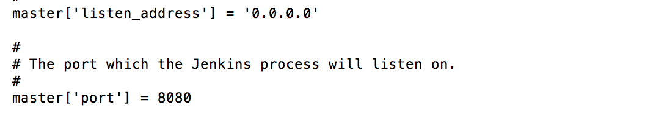

- There is a recipe master_package.rb in which we defined various plugins that needs to be installed.
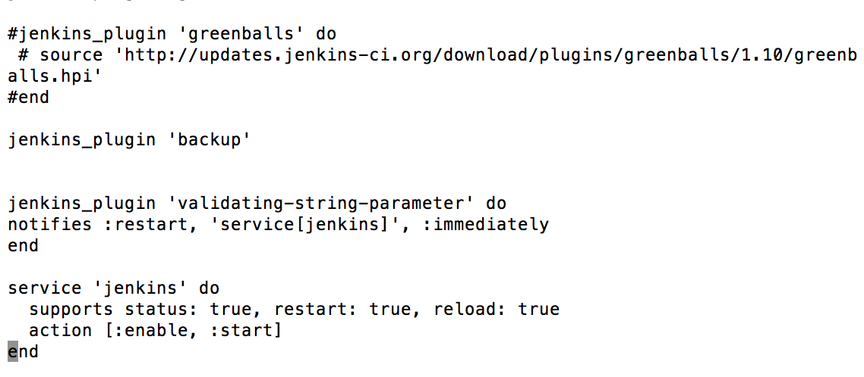

- Update config.xml file to provide the access to install plugins
- Upload the cookbook to chef server.
  - Knife cookbook upload Jenkins
- Upload validator.pem file from the chef server to s3 bucket.

Cloud formation Template to spin off EC2 instance with Jenkins server:

- Create a cloud formation template in such a way that it has all the parameters like key name, instance type, server name, chef organization and s3 bucket etc., by default.
- Modify the template to provide the interaction between the chef server and AWS. Need to invoke files like validator.pem, client.rbandnode.json.
- Lanuch the CFT from Jenkins to create EC2 instances.
- Created node.js on file where the recipe is included there.
- CFT will pull all the recipes from the server and it will deploy everything.
- Plugins are also installed automatically as per the recipe.

Conclusion:
We can develop the cookbooks like Tomcat, Weblogic, JDK, Test automation, Deployment automation and upload to server. We can kick off CFT with all the required cookbooks and start the testing automatically.

We can achieve the CD process using above architecture.

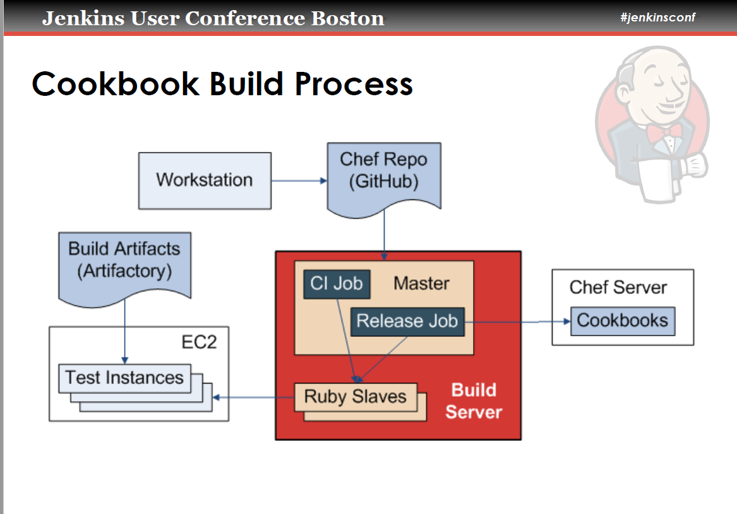

I have used attached document for reference.
